Automation Meets Operational Management

University of Mary

Max Bunkers

Advancement in technology has increased drastically in the last 70 years. Looking back to WWII when assembly lines built all the hardware for the war effort. Now automated machines build numerous products replacing the human assembly line to build the products. One automation process is computer integrated manufacturing. Computer integrated manufacturing is using automated machines to replace the manufacturing process of written and oral communication (Chase & Jacobs, 2018). Another is human automation controlled manufacturing which is more of a hybrid process. Innovation also plays a role in the manufacturing process for companies. Maintaining innovation is key to a company’s existence in the market they operate in. This is the future of manufacturing where someone places inputs into the computer to plan and schedule productions of the products the company is selling.

**Computer Integrated Manufacturing**

This process is using a computer integrated manufacturing to build manufacturing models that best suit a company’s manufacturing process. The plan is build processes that decrease the downtime of machine cost to allow for better production of the product (Wang & Chan, 2012). The programs being modeled are using the computer integrated manufacturing process with automated machines. This will continue to be developed over time and adjusted frequently. Computers will still have to be monitored by a human to ensure proper communication among the manufacturing line is correct. Issues will arise with the communication network of machines. Automation will not be a hundred percent effective all the time. Updates will be required along with routine maintenance. The computer program will be the main driving force of the manufacturing process and effective communication data for the machine to operate effectively will be monitored throughout the whole product design process. Communication has always been a key for human interaction and now it will continue to be a key for programs to communicate to the machine to perform the complex tasks of building products.

**Human Automation Manufacturing**

Another interesting automation process is human automation interactive manufacturing system control. The use of automation machines has removed the human aspect of difficult tasks replacing them with machines (Shin, Wysk, & Rothrock, 2006). This is good and bad for the company. The good being a employee does not have to do the difficult tasks putting strain on the human body. The bad is now a machine replaced the human and then that human could lose his/her job. Another bad for the company is getting the machines to do all the tasks it is required to do efficiently. That is where another human comes into play to program the machine correctly for proper use. Humans will still be a part of the manufacturing process but it will be in a different role. See Appendix A.

Although automation will have to deal with the highly complex manufacturing processes the human will have to be ready to help with the machine functioning effectively. The employee will have to ensure quality of the product being made by the machine and watching the machine throughout the whole process. The company can rely on the machine to make the product but if some error occurs the human will have to identify that will some sort of quality control. Automation is programmed and humans use certain computer integrated machine programs to perform the task at hand. When the machine malfunctions that is when the human steps in to correct the problem. Humans should still be able to control or manipulate all automated machines (Kim, Shin, Wysk, & Rothrock, 2010). This allows the human to correct problems that arise with the automated process. Machines are manmade and will result in some malfunction over time. Everything is built to the best of its ability but it will break down at some point. The benefit is the machine is breaking down instead of person’s body. The machine will do all the tough physical labor instead of the human performing that task.

**Innovation**

Using the human to control certain aspects of automation managing the machine is beneficial for company. Models are being used to identify ways for a human-automated controlled machine to reduce affordance to the human (Kim, Shin, Wysk, & Rothrock, 2010). This allows processes being streamlined and more efficient for the company. Resulting in cutting cost of certain processes and moving towards the future of manufacturing. Some employees will lose out on this approach but companies still have to be able to stay in business to compete with one another. Competition is healthy for all business but if one company gets farther ahead than the other the one company will be put out of business. Staying innovative throughout the whole process of advancing manufacturing process will keep companies in business for the future (Mallett, 2018). Change happens often now with the technology moving drastically from year to year. Manufacturing is one of those areas that use technology to increase effective production process. It takes both humans and automated machines to adapt these processes.

In conclusion, computer integrated manufacturing, automation, and innovation of the manufacturing process never stops. Program models of manufacturing will continue to be build and adjusted. The computer integrated manufacturing processes with become more common for companies all over the world. The factories building the product will have to rely on automated machines to get the product made. Innovative brands will use these advancing technology processes to take the company to the next level. Humans will be required to do less physical demand but more critical thinking demands. Making better program models to increase efficient production of products.

Appendix A. Shin et al.

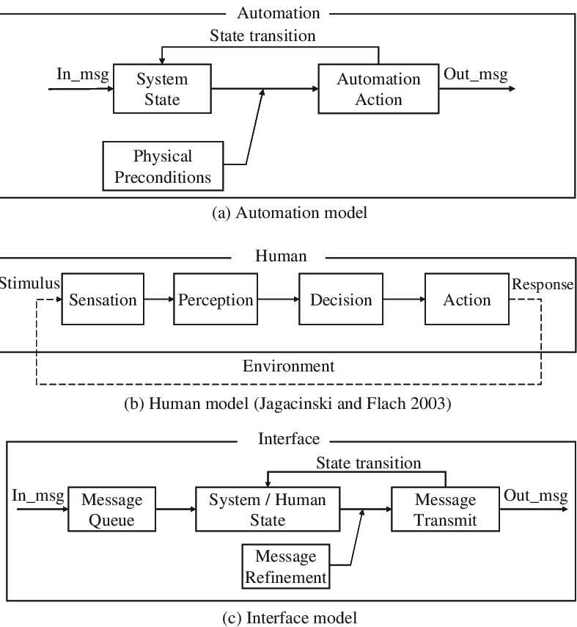

**References**

Chase, R., & Jacobs, F. R. (2018). *Operations and Supply Chain Management, 15e*. McGraw-Hill Education.

Kim, N., Shin, D., Wysk, R. A., & Rothrock, L. (2010). Using finite state automata (FSA) for formal modelling of affordances in human-machine cooperative manufacturing systems. International Journal of Production Research, 48(5), 1303–1320. <https://doi-> org.ezproxy.umary.edu/10.1080/00207540802582235

Mallett, B. (2018). Process Innovation in Manufacturing Supply Chains: The Path for Open Innovation. SAM Advanced Management Journal (07497075), 83(4), 4– 16.

Shin, D., Wysk, R. A., & Rothrock, L. (2006). A formal control-theoretic model of a human–automation interactive manufacturing system control. International Journal of Production Research, 44(20), 4273–4295. <https://doi-> org.ezproxy.umary.edu/10.1080/00207540500497074

Wang, L., & Chan, C. (2012). Formulation of a novel production line monitoring technique. International Journal of Production Research, 50(22), 6612–6623. https://doi-org.ezproxy.umary.edu/10.1080/00207543.2012.662304